Each spring, VMCCA juniors sit for one ACT testing session free-of-charge. Score reports are emailed to students and a copy is kept on file at school.

Once score reports are available, students can claim their ACT.org accounts to view and send scores. ***Students do not need assistance from VMCCA Staff to claim ACT accounts.***

*______________________________________________*

**STEP ONE:**

Visit my.act.org and select “Create MyACT account”.

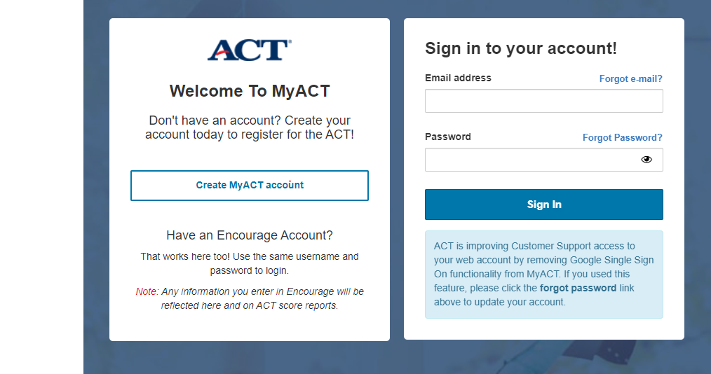

**STEP TWO:**

Select “I have registered or tested before”.

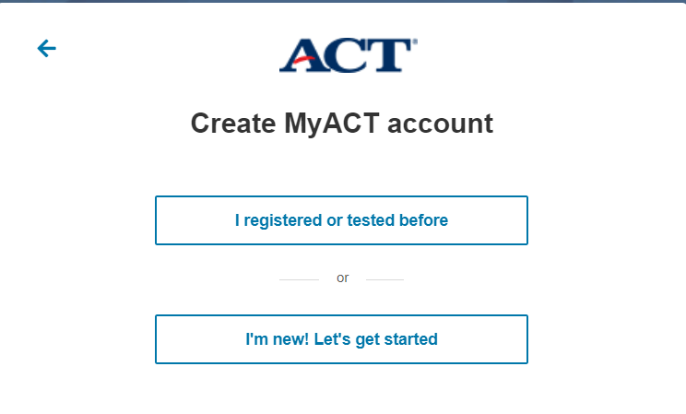

**STEP THREE:**

If you have accessed your scores online before, click that box and log in with the username & password you created. If you forgot this info, click “forgot user ID” and/or “forgot password”.

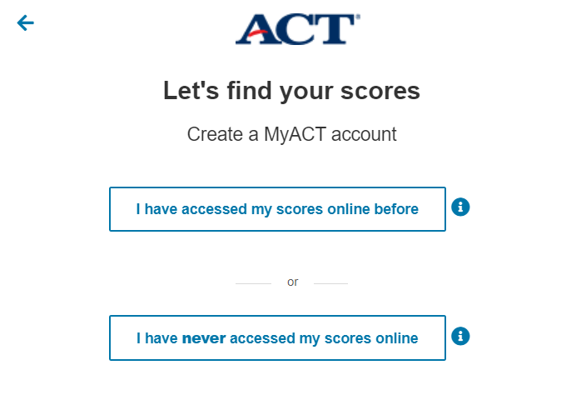

If you have **never accessed your scores online**, enter all personal information **exactly as it appears on your ACT Score Report**.

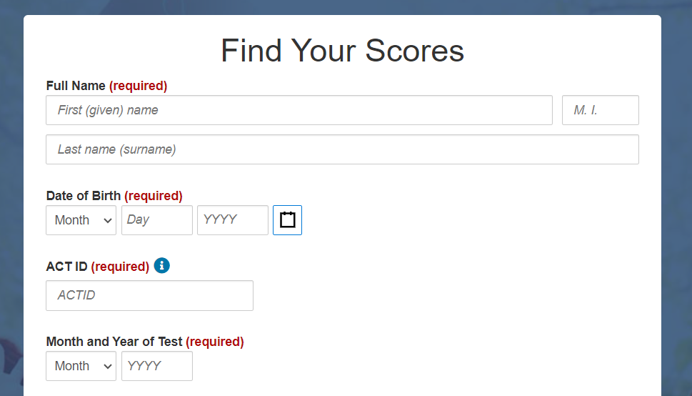

**TROUBLESHOOTING**

**If you followed these steps correctly, please call ACT Customer Care for assistance**. Unfortunately**,** VMCCA Staff cannot assist with these issues.

Phone: [319-337-1270](http://tel:319.337.1270/)